**Starter File**

Copy/paste the following into a Word file and place screenshots where you are asked. Complete this based on viewing the two videos "Responsible Image Download" and "Web Image Optimization":

**Next complete the following steps:**

Follow along with the Responsible Image Download video to learn how to find and save legal images.

1. Take a screenshot of your browser showing that you have located the usage rights options.

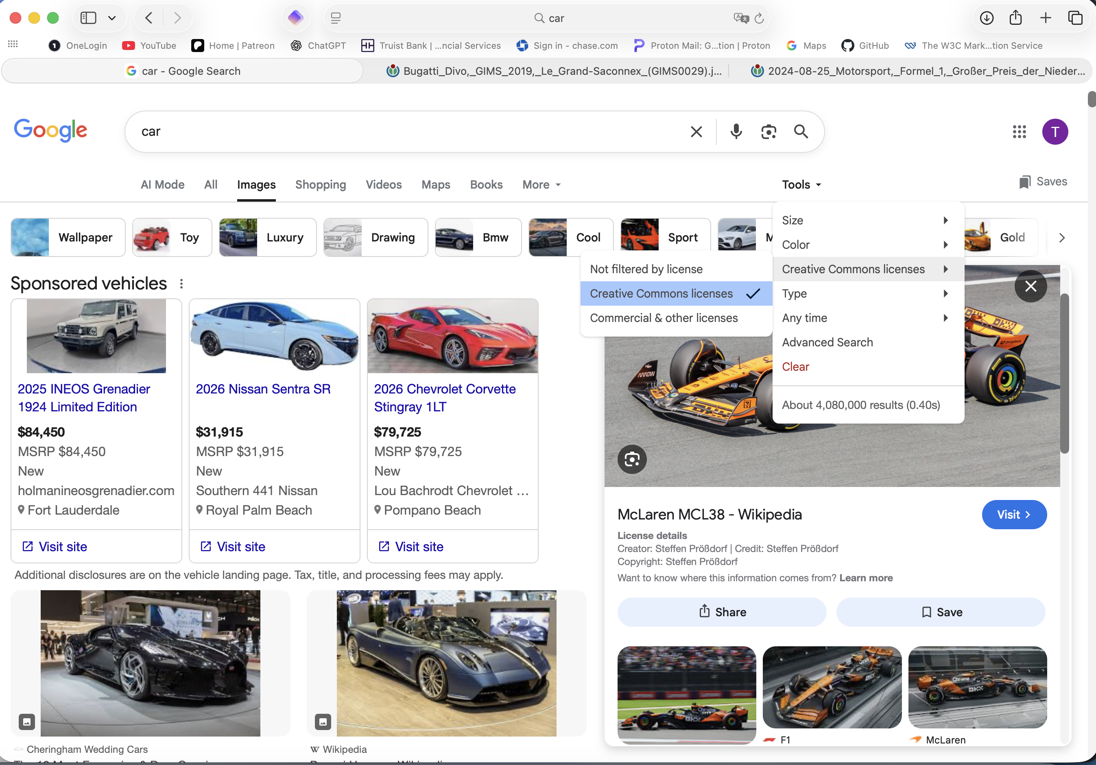

2. Find an image and an icon labeled for re-use and save them to a folder. Take a screenshot of the folder displaying the saved images.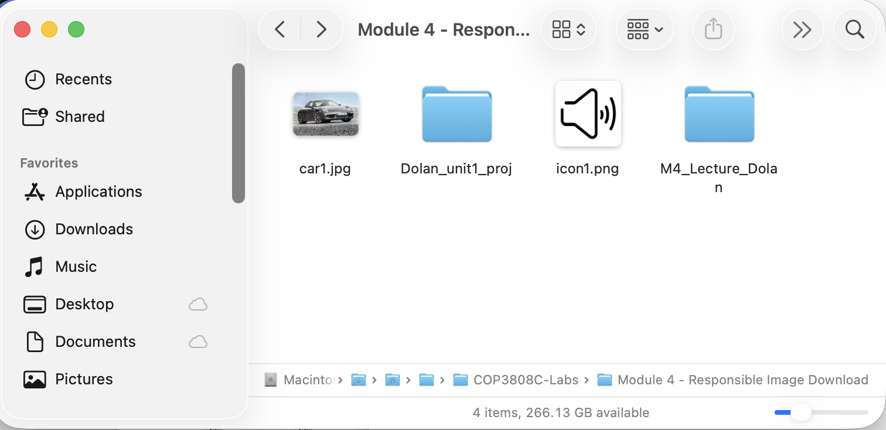

Next, watch the Web Image Optimization video and follow along:

1. Find an image labeled for re-use with modification. Make sure it will fill a screen 800 pixels wide.

2. Save the image as somesimplename_orig, no spaces, and a lower case jpg extension to your classwork folder, in a folder called raw (meaning original images).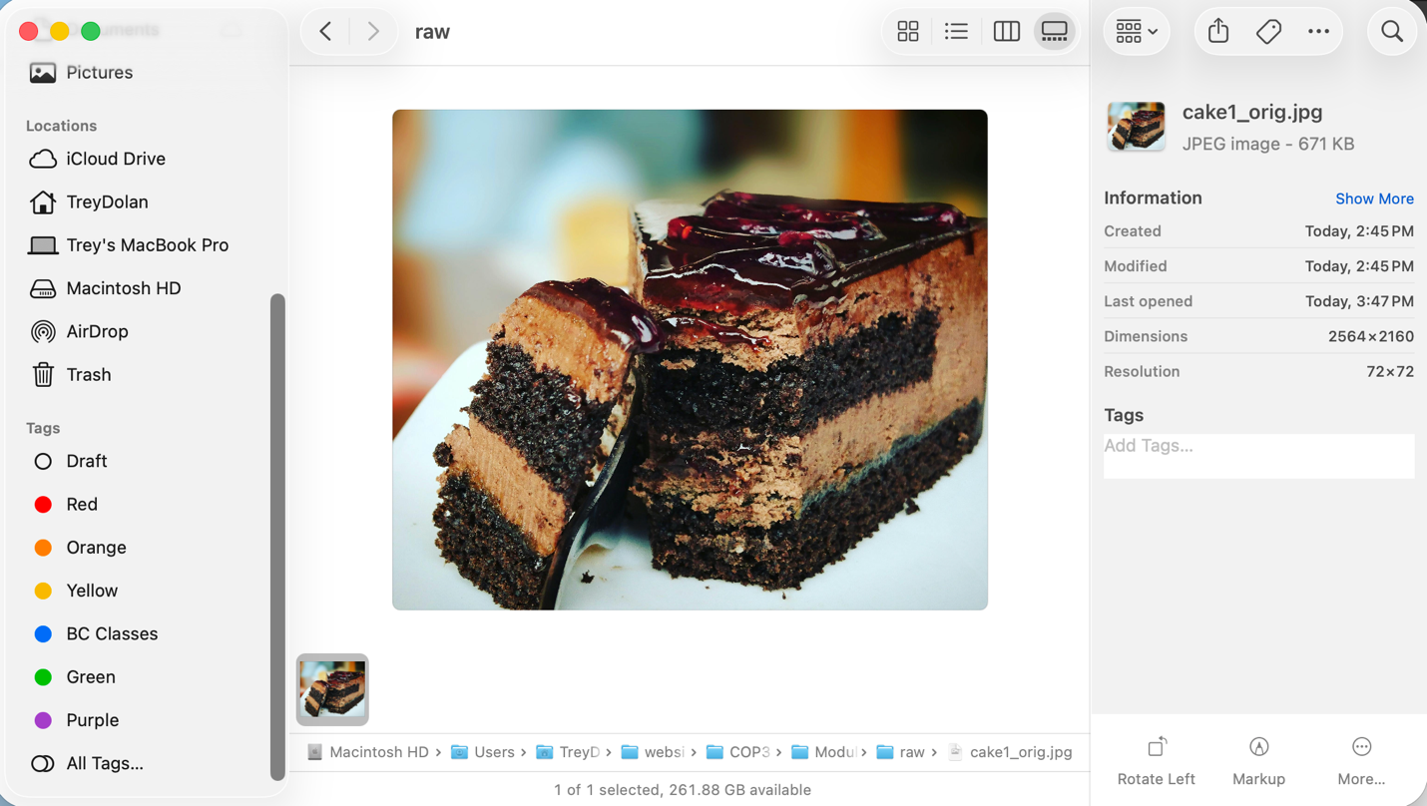

3. Launch Photoshop (or any image editing software you choose) and open the image. Find the original size and screenshot that size.

         Place the screenshot here.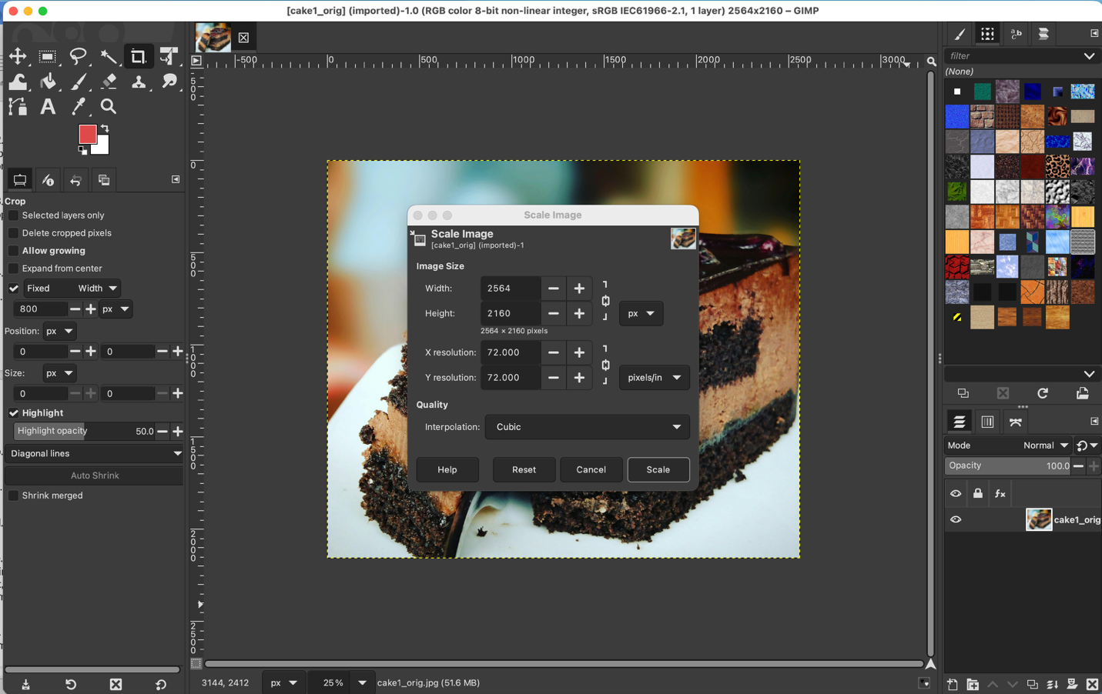

4. Export the image using "save for web."

a. Choose the jpg.

b. Scale the image size to a max of 800 width.

c. Set the quality to the highest and view the file size.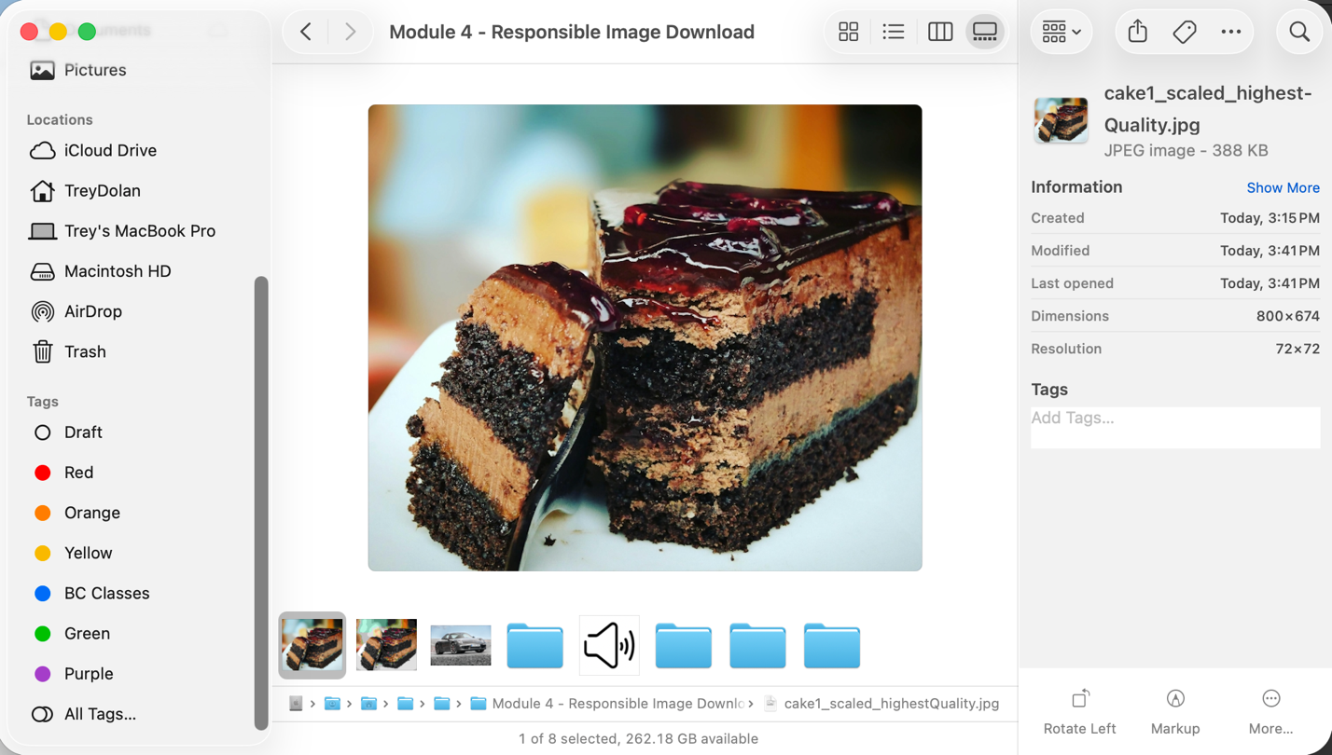

d. Set the quality to the lowest and view the file size.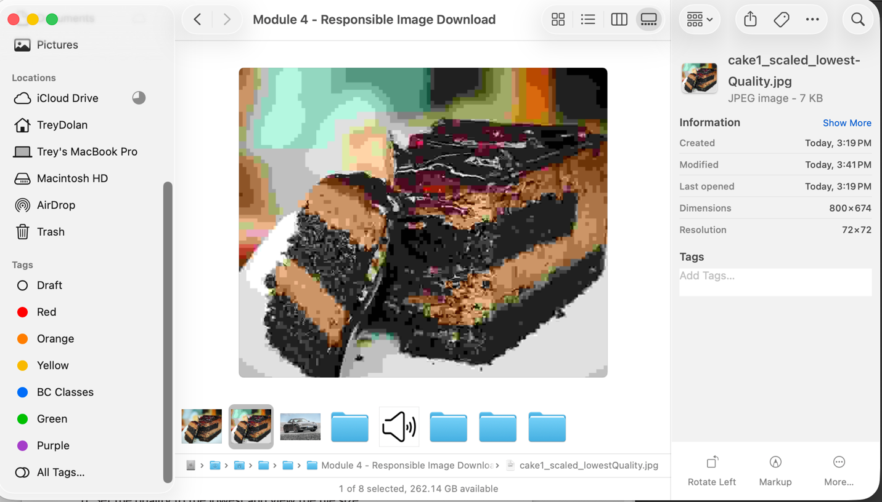

e. Finally, find the lowest quality that still looks good by changing it a few times (it will not be the absolute lowest). Once you find it where you like it, save the image as a new file in your classwork folder, in a folder called images.

f. Expand both folders (raw and images) to show the original and new image files (showing the file sizes too) and take a screenshot.

               Place the screenshot here.